| | Team name | 6droids | | --- | --- | | 14208971 | Tharkana D Kodagoda | | 14208893 | Sahitha Nelanga H De Silva | | 14208910 | H W Srimal Priyanga Fonseka | | 14209059 | Dilina Namal Weerasinghe | | 14209074 | P W Poorni Yasodara | | 14209759 | Kavindu Yudeesha Lakshan Narathota | |
| --- | --- | --- | --- | --- | --- | --- | --- | --- | --- | --- | --- | --- | --- | --- |
| Assignment – Object Oriented Design (COMP3004L) |
| Final Project Report |



Contents

1. Domain Analysis

2. Structural Diagrams

2.1. Class diagram

2.2. Object diagram

2.3. Component diagram

2.4. Deployment diagram

3. Behavioral Diagrams

3.1. Use case diagram

3.2. Sequence diagram

3.3. Activity diagram

1. Domain Analysis

| Client(Player) |
| --- |
| playerID:Integer |



| Game Rummy |
| --- |
| RummyGame |
| Draw |
| Discard |
| Card |
| Deal |
| Game Switch |
| SwitchGame |
| Draw |
| Discard |
| Card |
| Deal |

1. Structural Diagrams
   1. Class diagram



*Figure 1 - Class Diagram*

* 1. Object diagram



*Figure 2 - Object Diagram (Switch)*



*Figure 3 - Object Diagram (Rummy)*

* 1. Component diagram



* 1. Deployment diagram



1. Behavioral Diagrams
   1. Use case diagram



*Figure 4 – Use case Diagram*

* 1. Sequence diagram

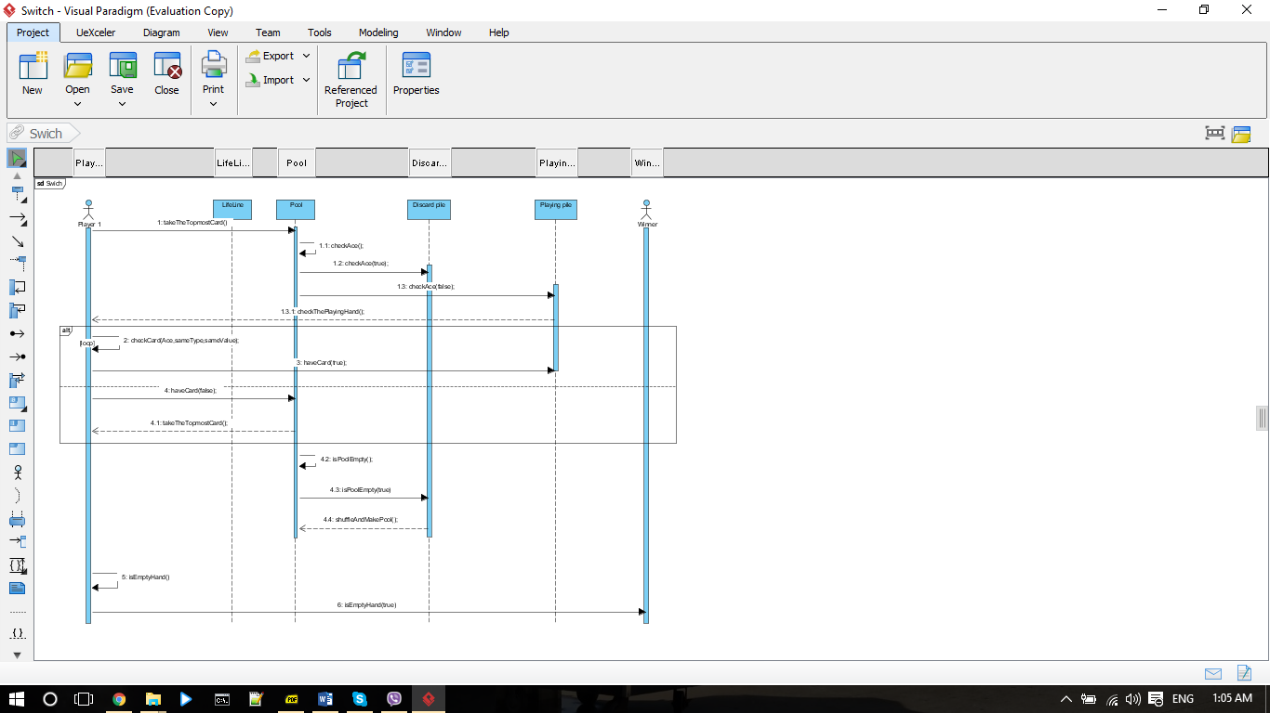

*Figure 5 - Sequence Diagram (Switch)*

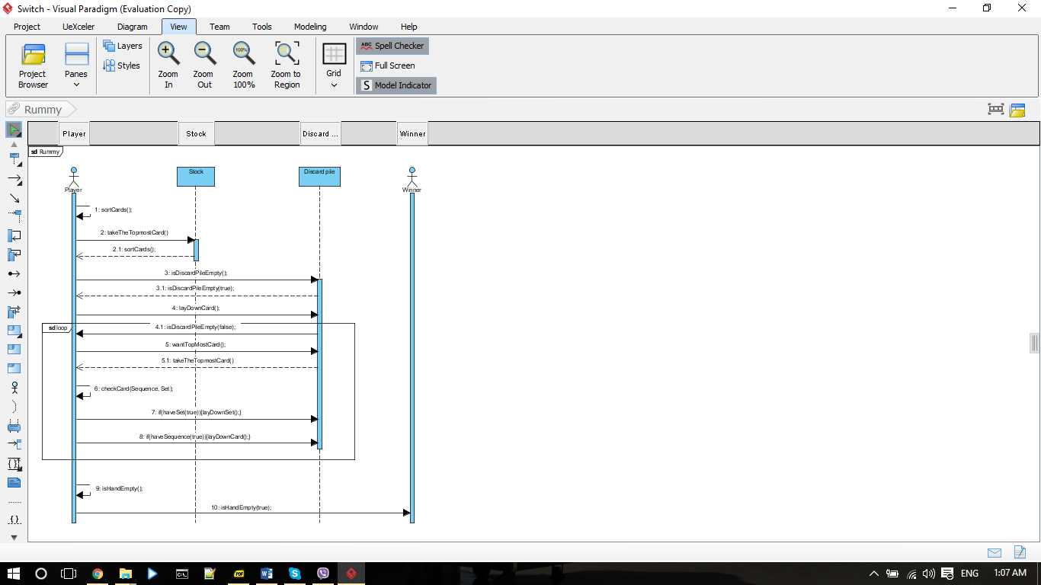

*Figure 6 - Sequence Diagram (Rummy)*

* 1. Activity diagram